Barkers Point Elementary School

Food Drive

December 2018
Barkers Point School is holding a FOOD DRIVE to support the School Lunch Program and the Backpack Program during the month of December. This support school lunches at our school and other schools across Fredericton. A list of the items used in these programs is listed below. We will also be donating some food to the Oromocto Food Bank as well.
100% Juice Boxes
Nut-free granola bars
Individually packaged nut-free snacks
Individually packaged dried fruits – raisins/cranberries, etc.
Fruit or pudding cups
Individually portioned apple sauce
Canned pasta sauce
Canned vegetables
Canned soup
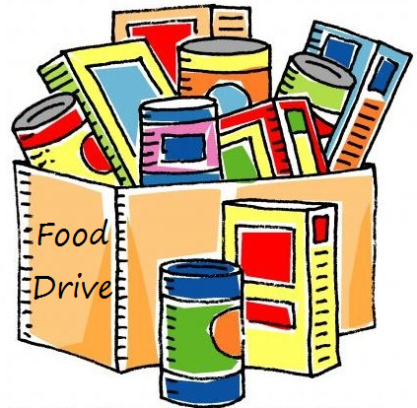
Pasta
Rice
Canned fruit
Individual packs of instant oatmeal
Canned meats – tuna/chicken/ham
Canned baked beans
Cereal
Powdered milk
Juice crystals
Tooth brushes
Toothpaste
Bar soap
Tissues
Toilet Paper
Sliced bread
Microwave popcorn
Sandwich bags
Brown paper lunch bags
Crackers
Cake mix
Muffin mix
Condiments – ketchup/mustard/mayonnaise

If you are able to help us out with these two worthwhile programs please send items in with your child or drop them off at the office anytime during the month of December. Thanking you in advance for your support!

